Model role play: Calling the ambulance service
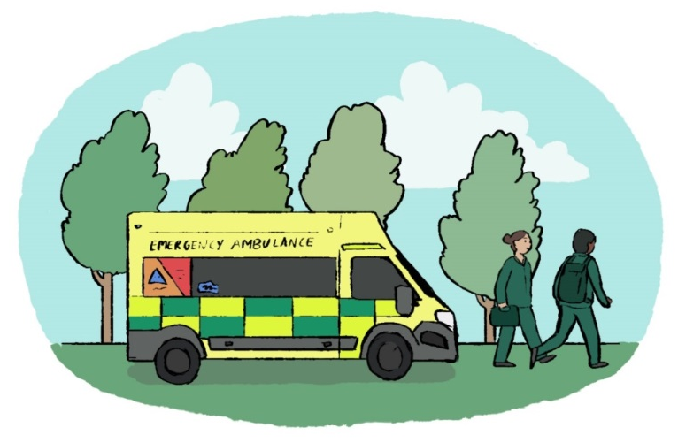
You will need a caller and an operator. Explain to the children that when making a 999 call they need to remember:
- to stay calm and speak clearly
- to tell the BT operator which emergency service they need
- to tell the ambulance service their address or location of the incident and phone number if they know it
- the emergency operator/call handler is there to help them and they shouldn’t be afraid.

BT operator: Hello, 999 which service do you need?
Caller: I need the ambulance service please.
BT operator: I’ll connect you now.
Ambulance operator: Hello, ambulance service. Is the patient breathing?
Caller: Yes or No
(You can tell if they are breathing by putting your ear near their mouth and looking down their chest to see if it is moving up and down)
Are they awake?
Caller: Yes or No
(Do you know why they ask these questions first? It’s so they know which the most serious calls are)
What’s the address of the emergency? Where are you?
Caller: Give your address if you can. If not describe what you can see around you or look for a letter with the address on.
Ambulance operator: What is the telephone number you are calling from? (Don’t worry if you don’t know what it is)
Caller: Number if known.
Ambulance operator: Tell me exactly what has happened.
Caller: Tell them exactly what has happened. (Ambulance operator: make up your own life threatening incident or use one of the scenarios from the ppt discussed.)
(Why do they ask for the address before finding out what’s happened? It’s so there is no delay in sending help!)
Ambulance operator: How old are they?
Caller: If you are not sure try to guess their age.
Ambulance operator: Thank you! Now I just need to ask you a few questions so you can help the patient. Help has been arranged. Please stay on the phone.

Remind children they should only ring 999 if it is a real emergency. Explain that calling 999 when it isn’t can stop real emergencies from being dealt with in the fastest possible time. If they remember this they will help save lives.

