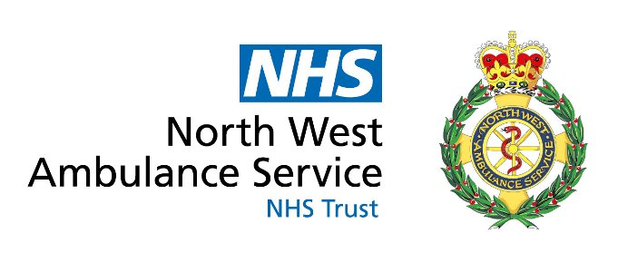
Health Professional Feedback Form

NHS 111 welcomes feedback about its services from patients, carers, health professionals and stakeholders alike. Listening to patients and all those who interface with our services provides a valuable learning opportunity which can be used to bring positive improvements to the quality of healthcare we provide.

Please use this form to record any feedback you wish to make, giving as much information as possible to enable us to identify the exact part of our service you are referring to. Please email your completed form to: nwasnt.111Clinical-Governance@nhs.net

If your feedback relates to a specific patient case or incident please complete the patient / call detail information below to enable us to identify and review the specific call.

IN CONFIDENCE

Health Professional Feedback Form
Name
Job Title
Organisation/Practice
CCG
Address
Telephone
Email Address
Date

Patient’s details (where necessary): Please give name, address & date of birth OR NHS Number
Name:
Address:
 | Postcode:
Telephone: | Date of birth:
Sex: Male □ Female □ | NHS Number (If Available):
Date of call to NHS111
Time of call to NHS111 (if known)
Risk Score (see matrix below)
Details of Feedback:
NB If you have any details of the outcome for the patient, please can you provide a summary as this will assist with call review

NHS 111 Investigation findings / response:

Categorisation and Complexity Risk Table
N.B
Low level issues (1&2) are recorded for trend analysis and acknowledged to the reporter
Level 3 issues will be investigated and responded to within a maximum of 40 working days
Level 4 / 5 issues will be investigated and responded to within a maximum of 60 working days
Category | Description /examples
- Serious 5 | - Patient death / life threatening harm as result of incident  - Catastrophic long term consequences  - Significant event impacting large number of patients – more than 50 affected  - Serious reportable incident (as per StEIS guidelines)
- Major 4 | - Major injury / illness leading to long term incapacity / disability as result of incident  - Major long term consequences as a result of the incident  - Increase in patients hospital stay or treatment by >15 days as a result of incident  - Serious mis-management of patient care with long term effects  - Potentially serious reportable incident (as per StEIS guidelines)
- Moderate 3 | - Moderate injury / illness requiring professional intervention as a result of incident  - Increase in patients hospital stay or treatment by 4 - 15 days as a result of incident  - Possible long term consequences as a result of incident
- Minor 2 | - Minor injury / illness requiring minor intervention as a result of incident  - Increase in patients hospital stay or treatment by 1 – 3 days as a result of incident  - Minor injury or illness with first aid treatment needed  - Single failure to meet standards / follow protocols
- Minimum 1 | - Minimal injury / illness requiring no / minimal intervention or treatment as a result of the incident  - No long term consequences

